|  |
| --- |
|  |
| Problem Statement |

# Problem Statement

A retail company Abstergo Corp. has recently setup an online shopping portal(website) to sell their products. Due to fierce competition, the company wants a solution that can reduce the time and effort it needs to enhance the functionality of their website on a regular basis. They are looking for an automated way to deploy the new code (for new features) to production website whenever they want.

# Business Requirements

* The team of developers working on new features will merge their code to a GitHub repo.
* As soon as the code reaches GitHub, using a CI (Continuous Integration) pipeline, setup in Jenkins, automated builds will be triggered.
* The automated builds will frequently deploy new features to the production website.
* Every build will prepare a Dockerfile and push docker images to docker-hub.
* Every docker image will be deployed (Continuous Deployment) to a kubernetes-cluster.

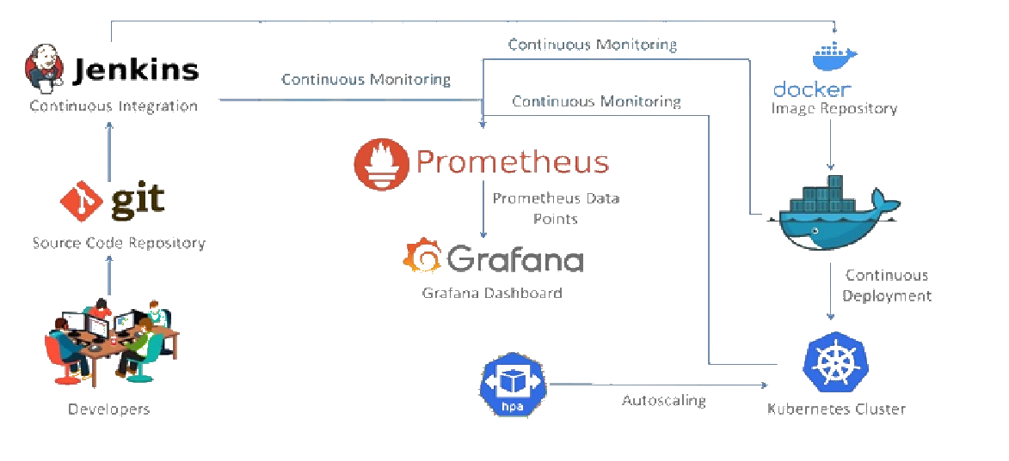

Fork the given repository to your own account and use it as the application for your pipeline project

**GitHub:** [https://github.com/bhavukm/cicd-pipeline-train-schedule-autodeploy](https://github.com/b#havukm/cicd-pipeline-train-schedule-autodeploy)

**System Requirements:**

Github setup — free account

Jenkins master - VM1

Build server - VM1

Monitoring framework - VM2

Production server – VM2